Profile  I am a hardworking individual who is always enthusiastic, optimistic, confident, and open to new experiences. I am an enthusiastic and goal driven IT student with experience in Java, HTML, JavaScript, Python, SQL, and CSS. I am currently working towards my BTech and PMI certification to become an IT Project Manager.  Contact  Phone:  060-767-3887  Email:  230055923@mycput.ac.za  Address:  8 Barkis Road, Lochiel, Cape Town, Western Cape, 7764  REFERENCES  Les Femmes Wellness Centre  Mrs. Shahieda Allie  info@lesfemmes.co.za  +27 21 762 0223  Tradeway  Ms. Tyla Felix  info@tradeway.co.za  +27 21 180 4644 |  | lAEEQAH ARENDSE  EDUCATION  Livingstone High School  2018 - 2022  I graduated from Livingstone High School in 2022 and received my National Senior Certificate. I achieved fourth place in my Matric year and received distinctions in Afrikaans, English, History Mathematical Literacy and Life Orientation. I completed the Project Management Institute (PMI) and JASA (Junior Achievers South Africa) Entrepreneurship program.  Cape Peninsula University of Technology  February 2023 - Present  I am currently in my third year of studying towards a BTech degree by first completing my Diploma in ICT: Applications Development which involves back-end and front-end coding, project management, professional communication & presentation, information management and systems, web design/development and software and hardware components. In my first year I achieved distinctions in Programming, Professional Communication, Project, and Communication Network Fundamentals. In my second year I earned distinctions in Professional Communication and Communication Network Fundamentals.  WORK EXPERIENCE  Tradeway – Promoter/Brand Ambassador  April 2024 – Current (Part-time)  My responsibilities involve in-store promotions and customer engagement.  Les Femmes Wellness Centre – Receptionist/Administrator  May 2023 – September 2024 (Part-time)  My responsibilities involved bookkeeping, administration duties, events planning, technical support, client bookings and correspondence. I was on the NPO fundraising committee as well.  SKILLS

Supporting Documents

Identification

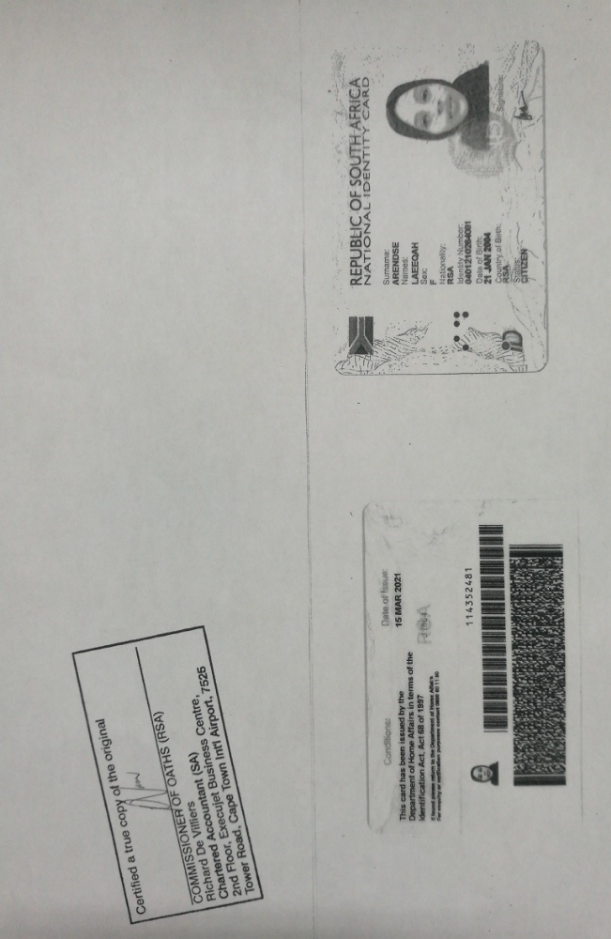

Matric Certification

